**10-11-2021**

First create the folder as

**Product Management System**

Then create two folder

Backend and frontend

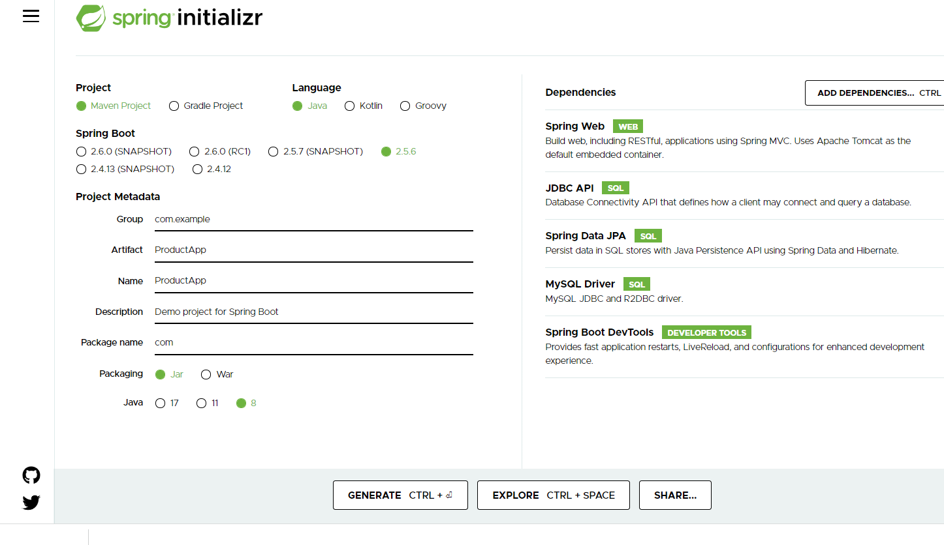

After created backend using Spring boot with Reset and Spring data

Write set of REST API methods.

Then create the Angular project

ng new angular-product-app

routing 🡪 yes

styling 🡪 CSS

ng g c product component

ng g s product service

ng g class product model class

Insert operation

Using Template driven form

We are running two application or domain

Front end running on port number 4200

Backend running on port number 9090

CORS : Cross Origin Resource Sharing

By default HttpClient get, post, put and delete method return type is JSON consider ie Response.

12-11-2021

RDBMS : Relational Database Management System

My SQL or Oracle or Db2 or Postgres SQL etc

All RDBMS Database are schema base ie

Table

Emp

Id Name Age city PhNumber

100 Raj 21 null null

101 Ram 23 null null

102 Ravi 26 Bangalore null

103 Ramesh null null 9900

In Angular side we are using JSON and Spring boot we are using JSON

In Old version to store the object or retrieve object we were converting Json Data into java object and vice-versa.

JSON Format

Front end side backend side database side

In Json value can be number, string , boolean array type, array object type, complex object etc.

{“id”:100,”name”:”Ravi”,”age”:21,skillset:[“Java”,”Angular”],”address”:{“city”:”Bangalore”,”state”:”Kar”}};

Mongo DB is type of No SQL database. It is open source allow to store the data in JSON format.

RDBMS Mongo DB

Database database

Table Collection

Attribute attribute or property

Records document

In RDBMS every records must be type in single table.

But in Mongo DB every document can be same or different in collection.

Default path for mongo DB server files are

In C drive create the folder with name as

data inside data folder create sub folder with name as

db

now open the command prompt in bin folder of mongo DB database folder.

Ie

C:\Program Files\MongoDB\Server\5.0\bin

To run the server we have to open the command prompt in inside bin folder and run the command as

mongod (this command is use to run the mongo db database).

Then open another command prompt to run the mongo client shell

mongo

to Clear the mongo shell we have to use the command as

Cntr + L

show databases

Or

show dbs

use databasename; This command is use to create the database and switch inside a database if database is not present if database present it switch to that database.

To check the collection (tables)

show collections

Or

show tables

syntax to create the collection

db.createCollection(“Emp”);

insert document in collection

db.collectionName.insert({key:value,key:value});

db.Emp.insert({name:”Ravi”,age:21});

now if want to view the document from collection we have to use the command as

db.collectionName.find();

db.Emp.find();

In Mongo DB we can insert the document inside a collection without creating collection.

If we want to retrieve specific property or properties from a collection.

db.CollectionName.find({condition},{filter property});

db.Employee.find({},{name:1}) : it is display name as well as _id pre-defined property

db.Employee.find({},{name:1,_id:0}) : it is display only name.

db.Employee.find({},{name:1,_id:0,age:1}) : it is display name and age.

Conditions

db.CollectionName.find({condition});

db.Employee.find({_id:1});

db.Employee.find({city:"Bangalore"});

relational operators

db.Employee.find({age:{$gt:25}})

db.Employee.find({age:{$gte:25}})

db.Employee.find({age:{$lt:25}})

db.Employee.find({age:{$lte:25}})

db.Employee.find({age:{$eq:25}})

db.Employee.find({age:{$ne:25}})

and / or conditions

db.Employee.find({$and:[{_id:1},{name:"Ravi"}]});

db.Employee.find({$or:[{_id:2},{name:"Ravi"}]});

update the document using some conditions

db.collectionname.update({condition},{$set:{property:value}});

db.Employee.update({_id:1},{$set:{age:30}});

db.Employee.updateMany({city:"Bangalore"},{$set:{city:"Pune"}});

remove the documents

db.collectionName.remove({condition});

Testing : Testing is use to find the defect or error or bugs.

Program

Input read a,b

Process compute sum = a+b;

Output write sum

Two types of testing

1. Black box testing
2. White box testing

Black box testing

Input Process Output

Username and password

Pass correct

Success

Else

Fail

If expectation and actual both are match test pass or fail.

White box testing

Input Process Output

Unit testing : Unit testing is a type of white box testing. Unit testing is use to check the individual unit of source code that code may be written in function or method or modules or procedure etc.

Java provided open source light weighted jUnit framework which help to do the unit testing.

public int add(int x, int y) {

int sum = x+y;

return sum;

}

Junit test case and test suite

Test case : it is type of junit test class which contains more than one test method which help to do the testing for particular functionality.

jUnit life cycle function or hook of jUnit

Test suite

Test case : it contains one or more than one test function which help to test the business logic functionality.

We can execute only one test case file.

Test suite : Test suite is use to execute more than one test case and test case contains more than one test function to test the business logic.

Test suite is a group of more than test cases.

In Test suite they use two annotation

Test suite is normal java class with annotation as

@Runwith(Suite.class)

And second annotation is

@SuiteClasses({provide all suite classes details here})

In Enterprise application every layer or tier depends upon another layer or tier.

Like

Controller is depends upon the Service layer

Service layer depends upon Dao layer

Dao layer depends upon resource layer

Resource layer depends upon the database.

Using mocking / fake : Controller layer do the mocking or provide the fake data of service layer.

Service layer can do the mocking for dao layer or provide the fake data.

Mockito / jMockit : these are open source framework we can do mock of object using jUnit or TestNG framework.

16-11-2021

TestNG TestNG is an automation testing open source framework.

NG “next generation”. Test NG is base upon the junit testing.

jUnit testing mainly to do the testing for functionality or methods.

TestNG mainly to do the end-to-end testing.

Using Test NG we can generate the report. we can check how many test are pass or fail. We can skip few testing methods.

We can do the testing selenium with TestNG

By default Test NG plugin not available in eclipse IDE.

TestNG framework provide the XML file. It is known as Test NG Configuration file which help to organize all testing methods properly. It allow tester or developer to handle more than test cases or classes, defined the test suite. Using this file we can control the flow the testing application.

Grouping the Test function :

TestNG provide group features to combine more than one test function part of different test classes.

17-11-2021

TestNG hook or life cycle methods.

Selenium Automation tools

Selenium is one of the open source and widely use Web UI (User interface) automation tools or suite. It support in all browser , platform and maximum all programming languages.

Like Java, Python, C# and JavaScript etc.

Selenium can be used to automation testing and be integrate with any automation tool like Maven, Gradle, Jenkin and Docker.

We can configure Selenium with jUnit as well as TestNG

Using Selenium we can do end to end testing.

If we want to do the Testing using Selenium

1. Selenium IDE
2. Selenium Web Driver : using any programming like Java or python or C# etc.
3. Selenium RC

In Selenium we have the set the property for respective browser.

System.*setProperty*("webdriver.chrome.driver", "C:\\Users\\91990\\Desktop\\Comviva Training\\Phase 2\\Phase 5\\chromedriver.exe");

Then we have to create the reference of respective browser

WebDriver driver = **new** ChromeDriver(); // it can be firefox, edge, ie or chrome

Then take the help of get method to open the web page.

driver.get(URL)

after read some property from page

then we can close the browser.

We have to read the DOM Data it may be text field, password field, radio button, checkbox, submit button or reset.

WebDriver class provided pre-defined method ie findElement() findElements()

These two methods take By class reference class parameter.

By class provide set of methods which help to search the data of DOM.

Like

className

id

tagName

cssSelector

etc

Selenium with TestNG or Junit

Docker : Docker is an advanced OS virtualization software platform that makes easy to create, deploy, and run the application in Docker container.

Virtualization: it is a software (Such as Hypervisor) to create a virtual version of a resource such as server, data storage or application or tools.

VMware software is to create virtual machine.

My Base machine contains 16 GM RAM

If I am planning to run Guest OS : Unix or Linux or Window or Mac

4 GB RAM for Guest OS.

At the same time if we want to execute more than one OS

10 OS.

1GB

Virtual Machine : VM is a computing environment or software that aids developers to access an operating system or system software or via physical machine.

Docker container is a light weighted container which allow the developer to package up an application and deploy it as with the help of build libraries and other dependencies.

VM ware software is use to achieve virtualization Virtualization software is a abstract version of physical machine. Docker is containerization is the abstract version of the application.

Container : Container are deployed application bundled with all necessary dependencies and configuration files also known as engine.

Docker container : Running instance of Docker images container turn the actual application or run the application. Container contains application details and dependencies.

Docker image : The file system and configuration of our application which is use to create the container.

We can create the image using Docker file.

Dockerfile : it is a blue print or set of instruction that defined how our images to build.

Docker registry : Docker registry is use to store or publish the more than one images.

Docker hub : Docker hub is like a github. In Github we can push any type of files but in Docker hub we can publish or store images so people can pull and run application in their machine.

There two types of registry we can create private and public. We can create only one private registry and we can create n number of public registry.

Docker commands

docker –version : This command is use to display the version of the Docker

docker images : This command is use to display all images available in our machine.

docker pull imageName: This command is use to pull the image from docker hub.

docker pull hello-world

docker run imageName or imageId: This command is use to run the images

**busybox image : it is a tiny Unix base OS.**

docker pull busybox

docker run busybox : run the image and stop the image

docker run –it busybox

alpine images

**Docker file**

FROM busybox:latest : pull the image from docker hub or local machine

CMD ["date"] : open the command prompt in os and run the command as date.

We have to save the file with name Dockerfile without extension.

Command to create the image using Dockerfile

docker build –t imageName . –f Dockerfile.txt

19-11-2021

Running simple Java programs using Docker image

Dockerfile

FROM openjdk:8

COPY Demo.java .

RUN javac Demo.java

CMD ["java","Demo"]

Syntax to create the image

docker build –t imageName . –f Dockerfile.txt

Running or creating docker images for Spring boot application.

First we will create the simple spring boot application.

Using maven command we have create the jar file

Open the command prompt to create the jar file for the spring boot application.

mvn package ( Run this command in spring boot project ie pom.xml)

if image contains web application then we have to run the image using command as

docker run –d –p 9292:9191 springboot-987

-d means detached mode

-p port number

Left side port number to expose can be same or different

Right side port number actual port number

Docker image for run the static web page

Nginx server help to deploy the static web page.

**What is nginx?**

This sever help to run any static web page, angular application or react application.

First create the simple html page or css or js

Dockerfile

FROM nginx:alpine

COPY . /usr/share/nginx/html

docker build -t my-html-987 . -f Dockerfile

docker run –d –p 80:80 my-html-987

default port number for nginx server is 80

creating docker image for angular application

First create the angular project

After development code then we have to build the project.

To build the project we have to use the command as

ng build

after build you can see dist folder.

Now inside build files create Dockerfile

FROM nginx:alpine

COPY . /usr/share/nginx/html

Create the image

docker build –t my-angular-987 . –t Dockerfile

After image created then you have to run the application

docker run –d –p 9999:80 my-angular-987

24-11-2021

dockder ps : this command is use display all contains running our machine

docker stop containerId : This command is use to stop the container.

How to publish the image in github account.

Before publish the image we have create the tag for the image.

docker tag imageName dockerHubAccountId/imageName:latest

docker tag my-angular123 akashkale/my-angular-123:latest

After created tag for the images then you can publish the image using the command as

docker push dockerHubAccount/imageName:latest

docker push akashkale/my-angular-123:latest

Container : container hold configuration details about the application.

So if we want to run more than one application we have to create more than one images and run those images.

I need to run 10 or 20 or 100 container which are communicating to each others.

Kubernetes : In Simple words, Kubernetes is an open source platform used for maintaining and deploying a group of or more than one container.

It is also known as container management (orchestration) tool.

In short Kubernetes also called K8s.

It use to maintain more than one container running in Docker environment.

Kubernetes initially part of google organization. Later on they donated it to NCNF (Cloud Native Computing foundation).

Container Management or Orchestration tool or engine automates deploying , scaling application and managing containerized application on a group of server or nodes or machine.

There are different type of tools are there

1. Kubernetes
2. Docker swarm (we configure yml file to run more than one application in one images).
3. Apache Mesos Marathon

Responsibility of Management tool

1. Deploying
2. Scheduling
3. Scale up or down
4. Load balancing

Kubernetes

Container

Management Orchestration tool

Deploying

Scale up or down

Centralized application scheduling

Docker Container load balance etc

Pods and Nodes

Kubernetes doesn’t interact with container directly all container ie may be one container or more than one container must be wrap in a box ie Pods.

Pods can have single or more than one container.

Pods must be part of node or machine. So nodes can contains one or more than one pods.

When you specify a pods, you can optionally specify how must CPU and memory (RAM) for each container needs. When container have resource request specified, the scheduler part of Kuberentes can make or take decision about which nodes to place pods on.

Installation for Kubernetes

Kubectl and Minikube

Kubectl : The Kubernetes command line tool allow you to run all possible Kubernetes operation. It is a client for Kubernetes API.

Minikube : Minikube is a tool which help to run Kubernetes locally in our machine. Minikube run in a single node Kubernetes cluster environment on our personal computer.

After started minikube now we have to create the deployment with the kubectl command

kubectl create deployment my-node1 --image=akashkale/my-kubernetes

After created deployment now you have to open the dashboard

minikube dashboard

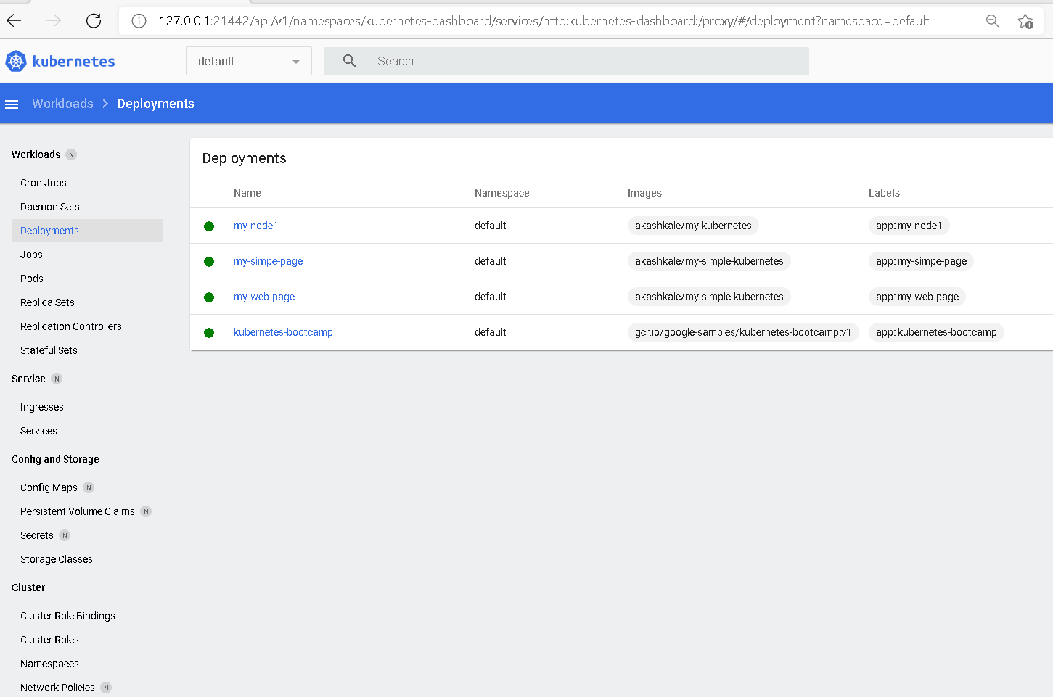

Then to check the pods details or to run the application we have to open another command prompt.

kubectl get pods

Now to run the application we have to use the command as

kubectl port-forward my-node1-f4f6bc85b-t9lqt 9999:80

Old Day of software development

Code changes made by individual team members are merged together into working software. Which is known as Integration phase.

Writing code

Merging code

Changing the code

CI and CD tools

Continuous integration and Continuous delivery

Jenkin is a open source automation server or loop written in Java. So with Jenkin integration phase run smoothly.

Jenkin detects changes in sub version tool ie git hub or git lab and perform task repeatedly(build, test, deploy and integrate).

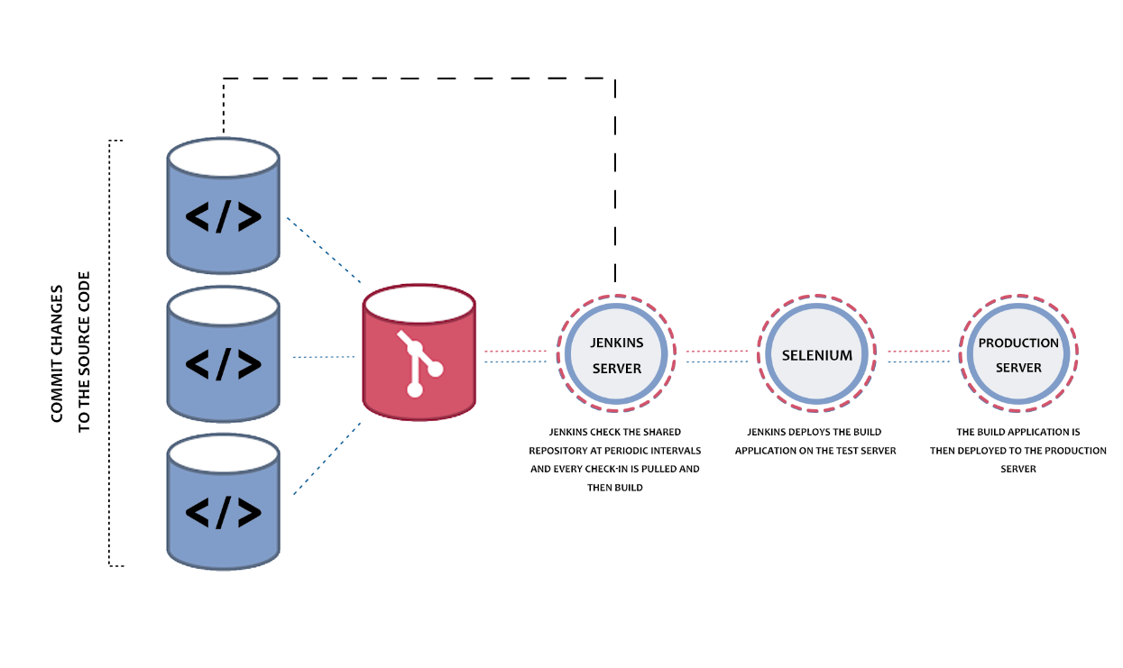

docker pull jenkins/Jenkins

docker run -p 8080:8080 -p 50000:50000 -v jenkins_home:/var/jenkins_home jenkins/jenkins:lts-jdk11

then open browser run the command as

<http://localhost:8080>

First time it will ask the password please copy and paste the password from terminal. And install the suggest plugins.

**25-11-2021**

AWS : Amazon Web Service :

Cloud computing

EC2 Amazon Elastic Compute Cloud : This is use to create the virtual machine with different configuration which help to deploy the application.